The Humanities at Kinder HSPVA
Dear Parents,

Welcome to Pre-AP World Geography! I am always excited to start a new year with new faces, and I truly look forward to getting to know your child.

Pre-AP World Geography is a challenging course with a great deal of outside reading. As the freshman teacher, I must take students from an uncertain (to me) middle school background at the beginning of the year, to being mentally prepared for a collegiate level course the beginning of their sophomore year at HSPVA. We presume that students enrolled in Pre-AP World Geography will be taking AP World History next year. Should you not be familiar with Advanced Placement courses, we do not set the curriculum for World History; rather the College Board does.

Having said this, many of you will agree that social studies was not always as academically rigorous in elementary or middle school as perhaps math and English. However, that is definitely no longer the case. For some of your students, social studies MAY have meant completing fill in the blank notes, coloring map outlines, and answering multiple choice tests. I feel it is important to let you know that none of that will be the case in Pre-AP World Geography. We will be reading a college level text, writing to the AP essay rubrics, and analyzing geopolitical events. I ask that you encourage your child as much as possible, while also understanding that getting an A in social studies is no longer a given. They can make the adjustment, but it will take time, often several months.

What is also most likely new to your student is the idea that they will be tested on material that is not necessarily covered in class. The model for AP World History is that the student will do the reading outside of class and learn the content from their text on their own. They will come into class ready for a reading check (quiz) and to use that information to complete historical argumentation and analysis. As this is what they are facing next year, I will do the same. Summative assessments in my class are open ended and will ask questions that we may not have discussed in class, but that de Blij has written about. It is necessary for them to truly engage with the de Blij text. I will be covering several different reading strategies in the first few weeks of class, and am always willing to try and diagnose issues in comprehension with your child. The amount of time it takes for your student to read with a high level of comprehension varies widely between students, although it is my hope that should your student pace themselves, reading time should not be more than 30-45 minutes every two days. They will occasionally have time in class to read, and can often catch up over weekends. However, they have a tendency to wait until the last minute…so if you realize that your child has been holding and complaining about the de Blij text for several hours at a time, they may need assistance creating a daily schedule!

Additionally, please be aware that our class will cover many sensitive, controversial, and debated topics. We will discuss religion, demography (and how different states deal with population issues including programs such as the One Child Policy or Japan’s efforts to increase their birth rate), climate change, the migration of hominins out of Africa, terrorism, world politics, globalization and other sensitive topics. The weekly freshman parent letter will outline the week ahead, including any videos and class topics. Should you ever need more clarification regarding the content of our classes, please do not hesitate to contact me at any time.

My website holds the calendar for the class, as well as many other useful bits of information on reading strategies (Learning Tools) and parent updates (I try to update these after each summative – I’ve left the first one from last year up on the Parent’s Corner). I am always available via email and conferences. For my records, please acknowledge receipt of the syllabus on the attached signature page and have your student return this to me.

I LOVE teaching this course having lived all over the world and I truly look forward to a great year!

Most Sincerely,
Jennifer Lankau Chase
Social Studies Chair
AP European History and World Geography
The Humanities at Kinder HSPVA

I have received the syllabus and parent letter for Pre-AP World Geography, and am aware of the student survey to be completed on www.chasetheworld.org.

____________________________ ____________________________
Student Name (print please!) Parent Name (print please!)

____________________date______ ____________________date______
Student Signature Parent Signature

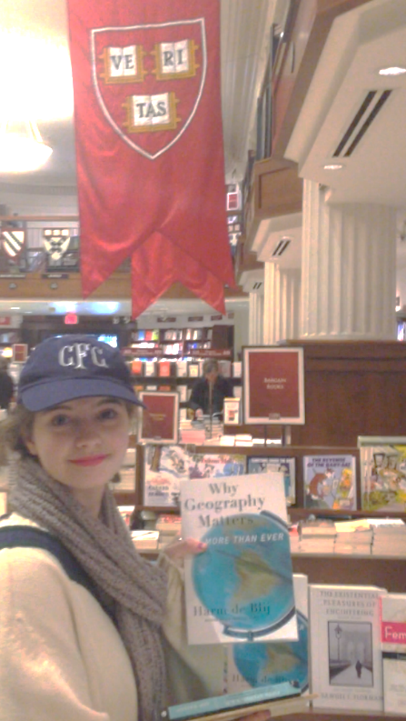

One of our former HSPVA students at Harvard’s bookstore…where she found de Blij’s Why Geography Matters…More than Ever. I promise that while it is quite challenging, it is good for you! It is what they are reading at Harvard!

