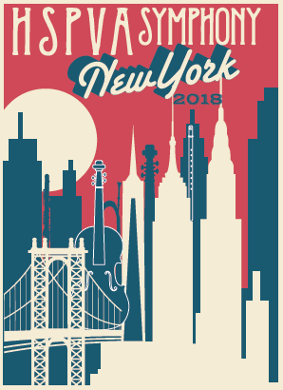
HSPVA Symphony Orchestra Packing List

Documents  - Identification with picture  - Copy of insurance card  - Copy of itinerary  Financials  - Money  - Debit/ Credit Cards  Travel Items  - Money belt/pouch or wallet  - Phone WITH CHARGER  - Umbrella or good raincoat  Toiletries  - Hair products (may not be enough provided by hotel for four people!)  - Towel (sometimes a problem at hotels  - Toothbrush  - Toothpaste  - Deodorant  - Brush/comb  - Shaving needs  Shoes  - Good walking shoes (it will be cold. Do not bring sandals)  - Black dress shoes for concert  Clothing  Thursday – dress at home! Jeans, walking shoes,  t-shirt, new Hoodie  Friday – warm walking around outfit that can convert  to Philharmonic concert in evening – leggings, cami or  solid t-shirt that you can add a sweater to, khakis o  NICE-intact-without-holes-jeans and sneakers (but  bring nice shoes in your day bag), etc.  - ______________________________  - ______________________________  - ______________________________  - ______________________________  - ______________________________  - ______________________________ | Clothing, cont.  Saturday – Concert Attire! And change for afternoon  evening.  Morning Concert Attire Women  - Black bottoms  - Black top  or  - Black dress  - Black shoes  - Skin tone hosiery if wearing a dress or black hosiery if wearing women’s trousers  Morning Concert Attire Men  - Black dress pants  - White dress shirt  - Tie (solid black silk or silk-like material)  - Black dress shoes  - Black socks  Afternoon Casual  - ______________________________  - ______________________________  - ______________________________  - ______________________________  Sunday – casual, walking around clothes  - ______________________________  - ______________________________  - ______________________________  - ______________________________  Monday - casual, walking around clothes  - ______________________________  - ______________________________  - ______________________________  - ______________________________

